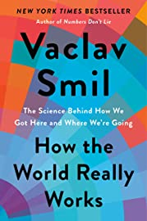 | Vaclav Smil, 2022  How the World really works: the science behind how we got here and where we’re going, 229 reading pages, Penguin Random House; ISBN 9780593297063 (hb); Nominated by Peter H.; 14 of 18 votes. The NAR team that will assist Peter in presenting this book includes: Alex, Jonathan, Larry, Jerry, Dudley, Piers, Brett, Walter, David, Rick, Debby, and Pat  (Nar Notes/Smil World Works)
SEPT 30 | PETER H. | Introduction  Ch. 1: Understanding Energy  Pp: 1 - 43
OCT 7 | BRETT | Ch. 2: Understanding food production  Ch. 3: Understanding our material World  Pp: 44 - 102
OCT 14 | ALEX | Ch. 4: Understanding globalization  Ch. 5: Understanding risks  Pp: 103 - 167
OCT 21 | ?PIERS & JERRY? | Ch. 6: Understanding the environment  Ch. 7: Understanding the future  Pp: 168 – 229  ROUND ROBIN CRITIQUE

